**Introduction to Rates, Ratios, and Proportions**

Rates, ratios, and proportions are representations that describe how two or more quantities are related. Scaling a recipe up or down requires a good understanding of proportions, and failing to hit ratios on a concrete mix could have a catastrophic impact on structures. Therefore, it is useful and equally important to be able to work with such relations. In this article, let’s discuss how to perform calculations on real-life examples.

**Rates**

Rates give us an idea about the change of a quantity with respect to another quantity. For example, if a car’s distance from a starting point is increasing by 30 miles every hour, then the rate is 30 mph. We can use this rate to answer questions like:

* What is the distance the car will travel in 2.5 hours?

We can use cross-multiplication to calculate the distance as shown below.

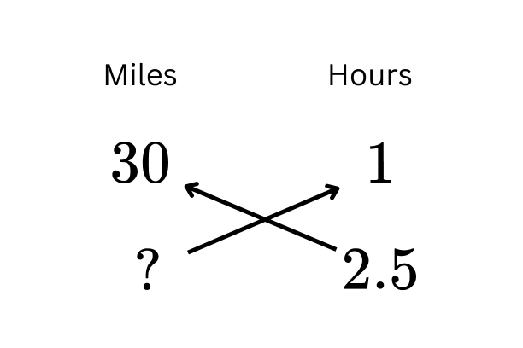

$30×2.5 = d×1$

$75 = d$

Therefore the distance the car travels in 2.5 hours is 75 miles.

* How long will it take for the car to travel 99 miles?

Here too we can use the same method, but remember that we have to include 99 in the miles column.

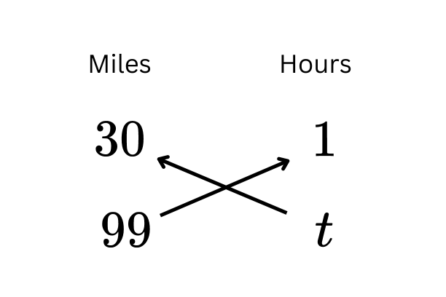

$30×t = 99×1$

$t = 99÷30$

$t = 3.3$

Therefore it will take 3.3 hours to travel 99 miles at the given rate.

**Ratios**

Let’s explore the concept of ratios using one of its well-known applications, aspect ratios.

The aspect ratio is widely used in describing image sizes, especially in cinematography, television, image editing apps, etc. The aspect ratio describes the relationship between an image’s width and height.

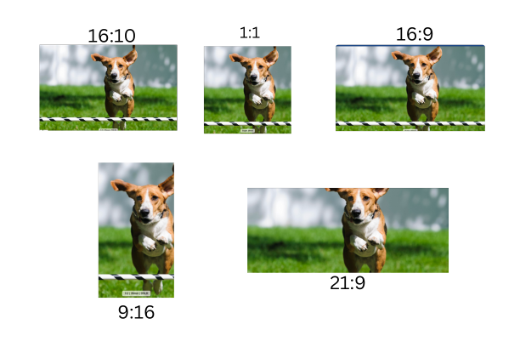

Some of the standard aspect ratios are:

* 4:3 - Video computer displays
* 16:9 - Widescreens and smartphones (horizontal)
* 9:16 - Smartphone vertical display
* 16:10 - Widescreen computer displays and smartphones (horizontal)

But what do these numbers mean?

Let’s take a 16:9 aspect ratio. To understand any ratio we need to know what each number represents. In an aspect ratio, the first number represents the width, and the next number represents the height. 16:9 (read as sixteen to nine) tells us that if the width of the display is 16 units, then its corresponding height would be 9 units. When carrying out calculations ratios can also represented as a fraction. 16:9 (sixteen to nine) would be $\frac{16}{9}$. Note that the order of numbers in ratios is crucial, changing it would represent an entirely different relationship.

We can have a deeper understanding of how to interpret ratios by walking through the following scenario:

Michael buys a widescreen television with a 16:9 display. If the TV displays an image that is 3840px wide, then what the the height of the image in px?

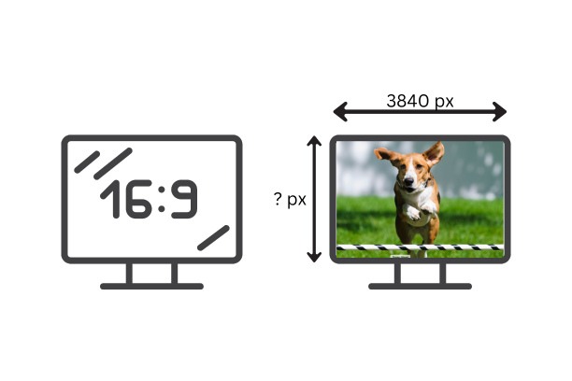

Here we need to set up a proportion. A proportion states the equivalence of two ratios.

We know that the image ratio must be proportion to the aspect ratio of the display, hence:

$\frac{16}{9} = \frac{3849}{?}$

We can cross-multiply to solve for the unknown height. As illustrated below, the height of the image on the display would be 2160, to maintain the 16:9 ratio.